# GAIN Main Website

In the following, I´m using the same period as the Index Website study (Sept. 14, 2011 until July 24, 2012), for comparison, but we are tracking visitors since before. This is specially important to measure the impact of the new website we made around November.

* Approximately 19.000 visits (11k less than the Index), of which at least 12,000 are unique visitors (8k less than Index).
* Each visitor viewed about three pages per visit (same as the Index), giving at total of 53,232 page views (85k the Index).
* The average visit duration was three minutes (4m20s for the Index).

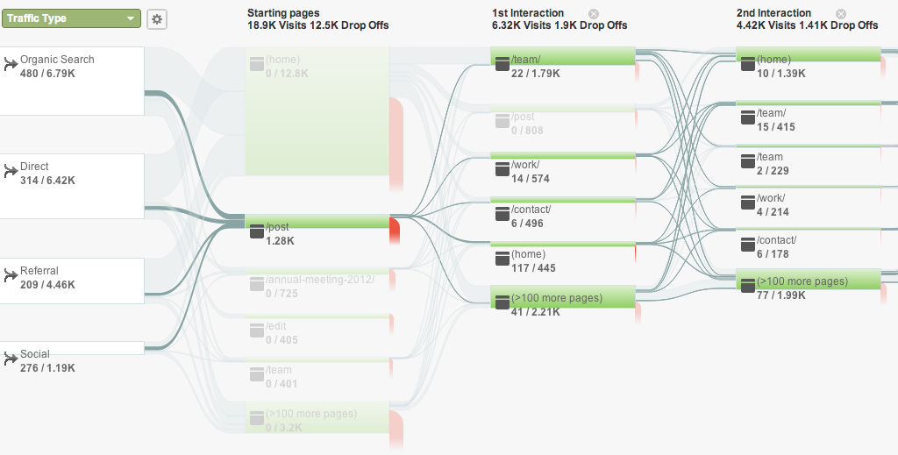

Figure . Visitor flow. From left to right, the first column is the breakdown by entry type: referral (link from another website), direct (typing the sites URL), ‘organic’ (from listings on search engine results pages like Google) or from social networks, the following breaks down the pages visited. Lines between columns show the thread of usage. Red lines represent the end of the visit. The highlighted connecting path shows those users who visited any Blog post as their landing page into our site (Breakdown of which one is shown on the Figure 2. Numbers below each green block correspond to visits towards this highlighted path, versus total views.

|  |  |  |
| --- | --- | --- |
| **“/post” breakdown** | **Visits** | **Drop-off rate** |
| /post/23110381344/climate-adaptation-in-mountain-basins-in-the-andean | 73 | 91.8% |
| /post/23185939346/gain-prize-winners-discuss-new-alliance | 67 | 80.6% |
| /post/27422616954/overcoming-inertia-advancing-corporate-leadership-in | 60 | 88.3% |
| /post/13543917035/durban-is-someone-missing-from-the-negotiation-table [[iew this link](http://www.globalai.org/post/13543917035/durban-is-someone-missing-from-the-negotiation-table)](http://www.globalai.org/post/13543917035/durban-is-someone-missing-from-the-negotiation-table" \t "GA_LINKER) | 46 | 87.0% |
| /post/16422641902/interview-the-emerging-business-and-regulatory | 39 | 100% |

Figure . Breakdown of the top Blog post that is accessed as an entry point to our website, as reflected in Figure 1. Drop off rate means user that left our site without exploring it further.

68% of our visits starts with the front page, most either direct or organic (not referral). Of these 61% drop out (could be to the Index site[[1]](#footnote-1)). The rest most likely go to the Team page, or the Blog post, or the Work Page.

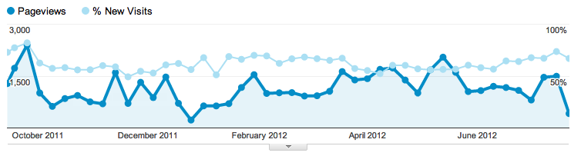

Figure . Timeline of page views per week from October 2011 to July 2012 in dark blue, and light blue for the percentage of new visitors.

Our average pageviews per week is around 1000 per week, which is similar of the Index site. Compared to the Index we have a slightly bigger share of New visits. Since we have less visits, this means we have less “visitor engagement” than the Index. This is related to the observation that the main site seems to lack the bumps of attention, which means would explain this behavior. Interesting.

The quick hypothesis here is that the Index site itself is sometimes picked up by news or blog posts, which create the peaks in visits (more pageviews and visits), but our background levels are similar. The audience are roughly similar so far, but they seem to like more the Index site than navigate into the Main site.

Figure . Breakdown of top page views on gain.org from Sept 2011 to July 2012. “/” refers to the main page. “Old” refers to the previous website we had before using Development Seed version.

The Front page gets most of the pageviews, 50% more than the share of visits of the front page of the Index site. This is in agreement with the significant drop-out in the visitor flow. 23% of the visits correspond to staff pages.

Figure . Traffic Sources.

Compared to the Index site, the main site is much more appealing to Organic searches.

10% of our visits come from the Index (17% of the Index site visits come from the main page). In absolute numbers 3.4k visits to the Index start in the Main site, and 1.5k visits to the Main site start in the Index).

The hypothesis to explain this is that the Main site gets less traffic but is much more likeable by Google (yet most landing pages correspond to the main page). On the other side, the Index site, with more visits, is able to provide as much traffic as Google.

Regarding search terms we are mostly appealing to obvious terms like “Global Adaptation Institute”, “Global Adaptation Index”. Less so but still in our top 10 are other terms like “Juan Jose daboub”, “gain” or “Ian Noble”

1. Index site and Main site are completely different in terms of web servers. I will install a tracker to know who “drops out” into the Index site. A rough estimate of this number can be calculated with some time [↑](#footnote-ref-1)